Show your Red, White and Blue
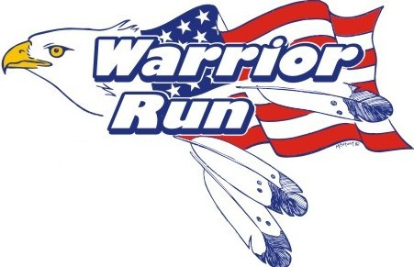

The 9th Annual Warrior Run
November 4th
Legacy of the Plains Museum
5K Walk/run and 10K Run
Kids Fun Run
Sponsored by
Webb Orthodontics

Sponsored by Great Western Bank

95% of proceeds go directly to helping Veterans and Military Families in the Wyobraska area!

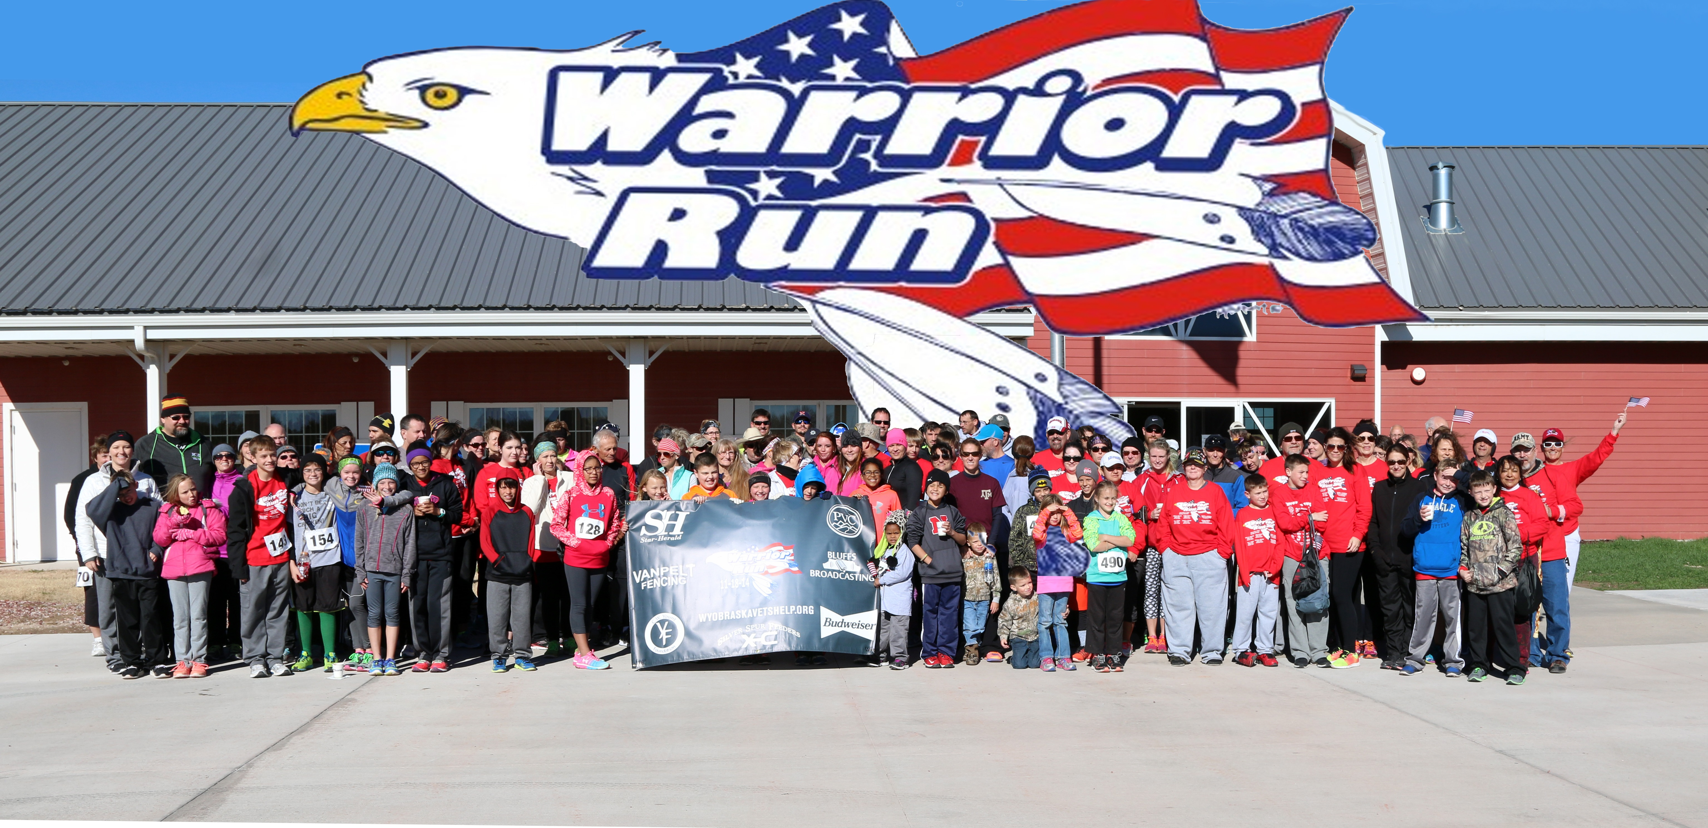Registration: 9:00 – 9:45 a.m.
5K-10K Races start at 10:00 a.m.

Webb Orthodontics Kids Fun Run will start around 11:00

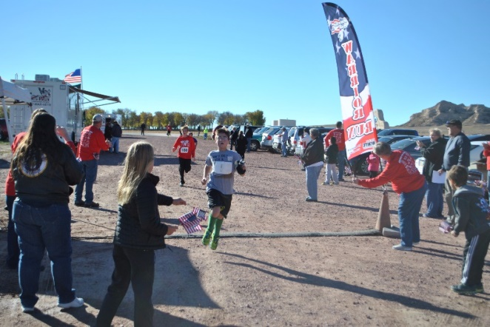
Registration fee:
Adults $30.00
Children (9-15) $15.00 Children’s Fun Run(under 9) are free
Family rate: 2 adults ($50.00)
and each child is $10.00

Registration deadline is October 28, 2017. Entries received after October 27st will have a $10.00 charge added for each adult.
Proceeds go to the Veterans and Military Families Emergency Relief Organization. For more information, go to www.wyobraskavetshelp.org

